PARISH NEWS
The Deverills & Crockerton

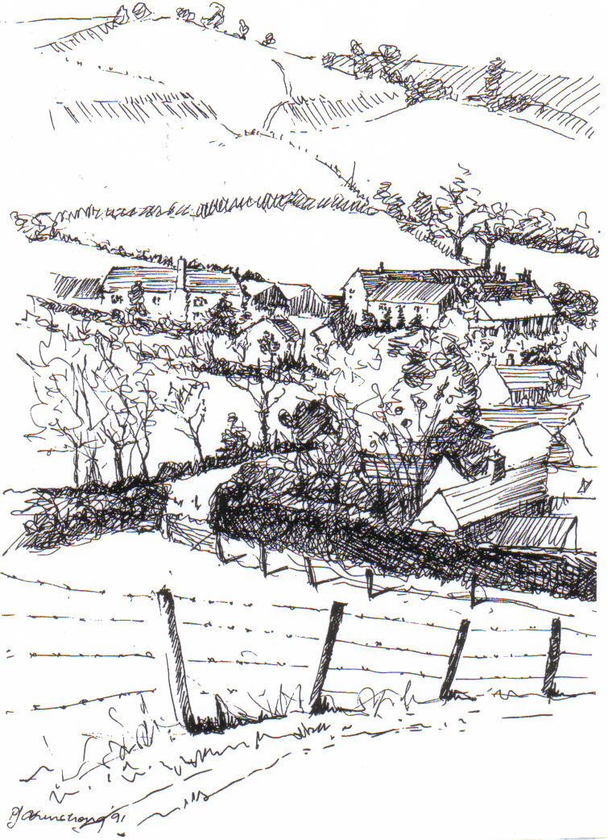

Kingston Deverill from Court Hill
by Pat Armstrong

August 2008

Look inside for local information
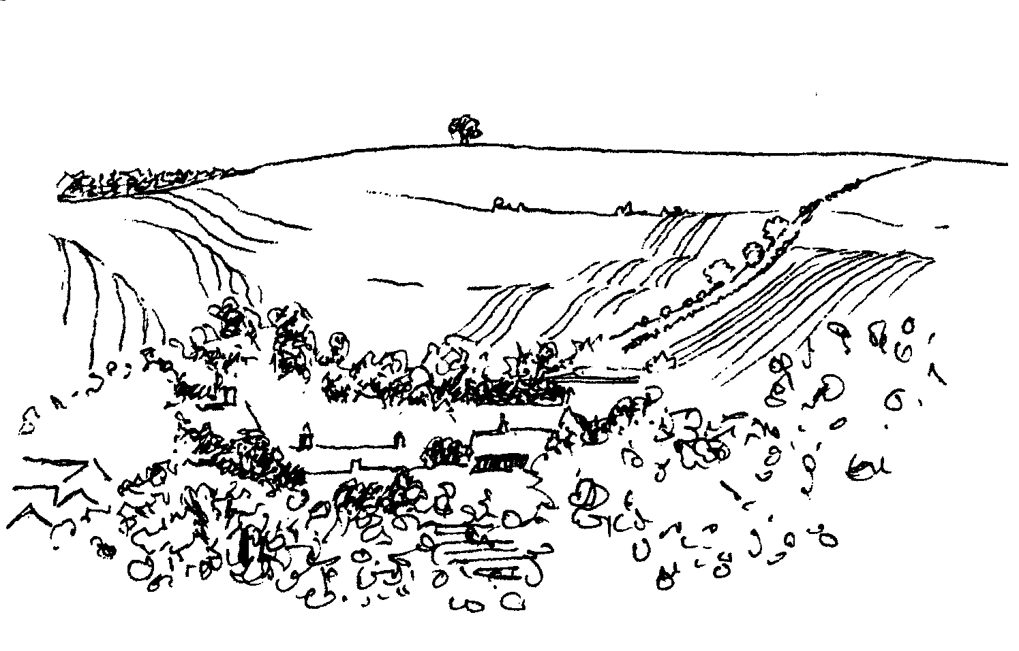

-2-
Deverill Valley & Crockerton Women's Institute
Monday 11th August 7.30 pm Longbridge Deverill Hall
Understanding Dementia with Gill Frere-Smith
Social time : Denman dowsing - Refreshments served
Come and join us, you will be very welcome
For more information contact Ann Dufosee 840360

Cream Teas and Open Garden in aid of Save the Children
Mill Farm House, Hill Deverill
Sunday 31st August
(and on the 28th September)
Cakes, plants and other interesting items for sale
Enjoy a relaxing afternoon in the barn or garden

SATURDAY 13TH SEPTEMBER

SUPPORT THE WILTSHIRE

HISTORIC CHURCHES TRUST

TO TAKE PART

PLEASE CONTACT

JUDY MUNRO 844385



CROCKERTON MILLENNIUM COMMITTEE
THE DUCK RACE
SUNDAY 28TH SEPTEMBER
1st prize £50, 2nd prize £25, 3rd prize £10
Ducks for sale at £1
Contact: Marion Thomas 213739, Tracey Mc Dermott 216939
or Trish Matthews 846613

-3-

The Rector writes:
I write this having just returned from our Diocesan Clergy Conference. The theme for our time together was ‘Can the Tree of Life survive climate change?’ The keynote speaker was Bishop George Browning, the recently retired Bishop of Canberra and Goulburn, who is an international expert on the theology and science of climate change. Bishop George has been involved in environmental issues throughout his ministry, so had much to share with us.
We hear a lot about the science around climate change, but we do not engage so easily in theological reflection about it. Bishop George began with Jesus, the Son of Man being Lord of all creation. As followers of Jesus this becomes our business as it is indeed God’s business, and it has to be worked out in our personal living.
Bishop George spoke of the whole of scripture being ‘sandwiched’ in the tree of life metaphor. The tree of life is mentioned at the beginning of Genesis and in the Book of Revelation. With the massive changes that are currently taking place will life survive? Can it survive?
We heard seven theological messages of central importance, summarised very briefly here:
- In the first creation story, humans were created from the earth. We have lost our relationship with the earth.
- We misinterpret the authority over creation given in Genesis. It is not the language of exploitation, but of care.
- Creation is a revelation: it reveals the nature of God.
- In the Wisdom literature, the wisdom of God is revealed in the person of Christ. God’s wisdom comes through the created order (see Psalm 19).
- In Deuteronomy, there is much about choice. ‘Choose life!’ we read. We can continue to do that only by making ecologically sound choices.
- We cannot believe in the gospel and not in the environmental challenge. Jesus is immersed in the world, in all of it, as Lord of all creation.
- Colossians 1:15ff is a wonderful hymn to creation. Both creative and redemptive activity are focused through Jesus.
Prosperity is about having choice: poverty is having no choice. We have a moral imperative to exercise good choices, not just for our own benefit but for the good of all, especially the poor.
Even if you think you have heard all there is to hear on this matter, I urge you to consider the matter again, and consider being really pro-active in the making of good choices about purchasing, about recycling, about ways to reduce your carbon footprint.
I, for one, want my children and grandchildren to be able to enjoy the earth and all that it offers. Being satisfied with what we have and knowing the difference between want and need is a good place to start!

Norma Payne

-4-

Bishop Ande and Dr Francesca visit
Many thanks are due to Julian and Sarah Algar for the generous loan of their Barn at Rye Hill Farm in June. The barn lends itself to informal parties with lots of space and equipped with plenty of large round tables and chairs. Thank you too to those who set everything out, to Janet Budgen who managed the bring and share supper table and to Helen Hemingway who organised the drinks. It was very good to have some people joining us from outside the Parish. I, for one, learnt a great deal about the Congo, an African country we only seem to hear about when there is internal strife but which is peaceful and democratically governed at present. Unlike many areas in Africa it is not suffering from famine, although there is poverty by our standards and the people live very different lives from ourselves. There is much scope for development. The Churches support the schools and provide medical care. The majority of Christians are Roman Catholic and there are a few Moslems. Bishop Ande is one of two Anglican Bishops who have had training in this country where he learnt English, which he speaks very well. The common language in Congo is French. One hopes he and his wife enjoyed their visits with Francesca to her twelve link parishes and that the Lambeth Conference widened their horizons. Our prayers and good wishes go to Bishop Ande and his wife and to Francesca for the future in the Congo.
Elisabeth Atkinson
Sponsored Ride and Stride
The Church of St Mary the Virgin at Kingston Deverill celebrates its Patronal Festival on Sunday 10th August. The building dates from 14th Century and has many remarkable features including the font and the effigy of a nobleman both discovered in the churchyard during renovation work in 1847. Wiltshire Historic Churches Trust provides grants to help maintain many beautiful churches in our county. Please take part or sponsor someone on Saturday 13th September in the Ride and Stride which is the Trust’s annual fund raising event. For further information and sponsor forms please contact me.
Judy Munro 844385
Music in the Deverills
4+1 Jazz Band - leader Bob Jones
New Orleans and Dixieland Jazz
8.00 pm Friday 12th September in Brixton Church
Tickets £10 (glass wine) in advance from Mary Stewart Cox 840877
Pre-concert supper 6.30 pm
At Brixton Manor House by kind permission of Johnny & Pony Burridge
Tickets £8 per head in advance from Mary Stewart Cox 840877
All profits to the Deverill Valley Churches Fabric Fund
(Bring a cushion!)
Music in the Deverills
4+1 Jazz Band - leader Bob Jones
New Orleans and Dixieland Jazz
8.00 pm Friday 12th September in Brixton Church
Tickets £10 (glass wine) in advance from Mary Stewart Cox 840877
Pre-concert supper 6.30 pm
At Brixton Manor House by kind permission of Johnny & Pony Burridge
Tickets £8 per head in advance from Mary Stewart Cox 840877
All profits to the Deverill Valley Churches Fabric Fund
(Bring a cushion!)

-5-

Why bother with fair trade?
“If you choose to buy the non-Fairtrade product, you are actively choosing to contribute to the poverty of others”. John Sentamu, Archbishop of York
Most of us are familiar with fair trade. But there’s truth in the old adage that familiarity breeds contempt. Take a moment to consider the implications: for NON-fair trade products, we do not know whether producers work in safe conditions, are paid enough to live on or have any chance to develop their communities. In fact, we know the stark reality is that many supply chains shamelessly exploit workers and keep millions trapped in poverty. As a prophetic action to demonstrate another way, a group of Christians started Traidcraft. Through the support of thousands of Christians, the fair trade movement has seen huge growth - but with this success comes greater competition for Traidcraft. Traidcraft’s role is still crucial: it is dedicated fair trade organisations like us which pioneer innovations in fair trade, support producer groups and seek new groups who desperately need the development fair trade allows.
Your Traidcraft stall needs your support. We know you can buy Fairtrade products more cheaply in the supermarket - but where does the profit go? To shareholders. Buy from a Traidcraft stall and you are supporting an organisation which exists to fight poverty through trade; a company which measures its success, no by profit, but by its volume of purchases from the developing world.
The 3 billion people living on under $2 a day have hope in the Traidcrafts of this world, which work to bring the benefits of trade to those who need it most. Supermarkets play a role by growing volumes of purchases to existing Fairtrade producers – but these fair trade groups would not be there at all if Traidcraft and organisations like us had not invested in and worked with them.
There are millions more which still need this chance. Traidcraft stalls are the backbone of everything that Traidcraft does. If you already support your stall – thank you! If not – why not start today?
Jane Riley Traidcraft Business Development Manager

Macmillan Cancer Support

World’s Biggest Coffee Morning

Crockerton Garden Centre

Friday 26th September

10.00 am till 12.00 noon

For any further information contact Janet Budgen 218203


-6-
3Peaks Challenge 2008
After an 11 hour drive on Saturday 21st June we finally arrived at Fort William, where the weather forecast was not good. The next day, Sunday 22nd June, in the afternoon 71 teams were bag-piped off up the mountain at two minute intervals. Our team of four was away at 17.20 hours, quite an emotional moment, Simon (Hurd) and Steve (Jeffries) our drivers, waved as we marched forward into the unknown. Just 2.12 hours later through rain and wind we were at the summit of Ben Nevis, -25º C wind chill, snow and no visibility, we didn’t hang about so made our way back down in 2.11 hours. We got straight into the waiting van, changed our clothes, had some food and tried to sleep, slumped across two seats in sleeping bags. It was onwards to Scafell Pike, a 6 hour drive.
An early start 4.12 am, definitely the hardest of the three. It was very wet under foot, we even had to cross quite a raging stream, hopping over rocks, but still getting our wet feet. Again at the summit there was no visibility, but at least it was not as cold. Walking down the mountains at a good pace is extremely hard on the knees. We managed a time of 4 hours. We again jumped straight into the van to go onto Snowdon, a 5 hour drive.
A gruelling 1 hour 54 minutes to the summit but this time we could see from the top, it was an amazing view and such a sense of achievement, something that will stay with me forever. We finally arrived back at the van where Simon and Steve were waiting yet again.
We had barely had any sleep in 24 hours but we managed a climbing time of 10.37 hours, the overall time being 21.37 hours and a gold medal! Thanks goes to Simon and Steve who had less sleep than we did and drove hundreds of miles, also to the other team members Caroline, Rebecca and Sarah.
I am absolutely delighted that I raised £630 which will be gratefully received by the RUH Forever Friends Appeal and Fire Service charities, thanks to the generosity of many of you. Onwards and upwards!
Julie Hurd
Exam Results time
These GCSE answers would have caused amusement but few points I fear:
- Ancient Egypt was inhabited by mummies and they all wrote in hydraulics. They lived in the Sarah Dessert and travelled by Camelot. The climate of the Sarah is such that the inhabitants have to live elsewhere.
- Gravity was invented by Isaac Walton. It is chiefly noticeable in the autumn when apples are falling off the trees.
- Eventually, the Romans conquered the Greeks. History calls people Romans because they never stayed on one place very long.
- Queen Elizabeth was ‘The Virgin Queen’. As a queen she was a success. When she exposed herself before her troops they all shouted “Hurrah”.

-7-

Upper Deverills Village Hall
Upper Deverills Fete, Flower & Dog Show
The Committee wish to report another resounding success for this year’s Fete, Flower & Dog Show. The weather was kind to us and the event was very well supported. We wish to thank all those who cooked scones and cakes, set up and managed the various games and stalls, contributed exhibits and entered their dogs and finally stayed afterwards to help clear up. Proceedings are still being counted but will go to Village Hall funds and we will announce the final count in the September magazine.

Competition Results
Village Hall Cup (Flowers and Vegetables) Angela May
Liz Peters Cup (Arts and Crafts) Avril Cousens
Junior Shield Henry Dufosee
WI Cup for Cookery Allison Dufosee
Molly Walker Cup (Best exhibit) Judy Munro
Dog Show Cup Grace
Postponed Duck Race
The race will now take place on Saturday 23rd August at 6.00 pm. The decision to postpone the Duck Race proved correct with all the rain that fell on the planned Saturday evening and in the following few days. We were sorry to disappoint everyone but hopefully the weather will be better in August and there will still be enough water in the river! By way of compensation we will have a competition for children of the best-decorated duck, with a suitable prize. Ducks will be on sale from 6.00 pm at Popes Farm Bridge, Kingston Deverill and the race will start at 6.30 pm. This popular event will be followed by Jack’s Barbeque in the field next to the river at the end of the race.
Future Events
Please make a note in your diaries of the Eddie Mirzoeff Film Night on Friday 3rd October and the Harvest Supper on Saturday 18th October.
Albert Lee
Deverills Cricket Club
The season continues with an excellent fixture list and hopefully fine weather. If you would like find out about joining the Club come to our next match or you can contact Peter Child on 01963 34593 or Jamie Fagan on 01985 844123 who will be able to tell you all about it. Our remaining home fixtures are on:
3rd, 24th and 25th August, 14th September

-8-
SERVICES PARISH OF DEVERILLS & HORNINGSHAM
Sunday Trinity 11
3rd August Kingston - 8.00 am Holy Communion 1662
Canon Richard Askew
Longbridge - 10.30 am Morning Worship
Rev Norma Payne
Horningsham - 6.30 pm Evening Service
Rev Norma Payne

Sunday Trinity 12
10th August Kingston - 10.30 am Patronal Holy Communion
Rev Norma Payne
Horningsham - 11.15 am Holy Communion 1662
Rev John Goodden

Sunday Trinity 13
17th August Longbridge - 8.00 am Holy Communion 1662
Rev John Goodden
Brixton - 10.30 am Holy Communion
Rev Norma Payne

Sunday Trinity 14
24th August Longbridge - 10.30 am Holy Communion
Rev Norma Payne
Horningsham - 11.15 am Morning Prayer
Col Robin Chappell
Brixton - 6.00 pm Evening Prayer
Mr John Budgen

Sunday Trinity 15
31st August Longbridge - 10.30 am Benefice Service
Revs Payne & Britten

Sunday Trinity 16
7th September Brixton - 8.00 am Holy Communion 1662
Longbridge - 10.30 am Morning Worship

Tuesday, Wednesday, Thursday, Friday Longbridge 8.30 am Morning Prayer

Wednesday Longbridge 10.15 am Holy Communion

-9-

SERVICES PARISH OF CORSLEY & CHAPMANSLADE
Sunday Trinity 11
3rd August Corsley - 9.00 am Family Holy Communion
Revs Payne & Britten
Chapmanslade - 3.30 pm Tea Service Picnic
Rev Di Britten
Sunday Trinity 12
10th August Chapmanslade - 9.00 am Holy Communion
Revs Payne & Britten
Temple - 11.00 am Patronal Morning Prayer
Rev Di Britten

Sunday Trinity 13
17th August Chapmanslade - 9.00 am Family Holy Communion
Rev Di Britten
Corsley - 2.30 pm Baptism
Rev Norma Payne
Corsley - 6.00 pm Evening Worship
Rev Di Britten
Sunday Trinity 14
24th August Temple - 9.00 am Holy Communion 1662
Rev Di Britten
Corsley Show Ground Service
Revs Payne & Britten
Sunday Trinity 15
31st August Longbridge - 10.30 am Benefice Service
Revs Payne & Britten
Sunday Trinity 16
7th September Corsley- 9.00 am Family Holy Communion Chapmanslade - 3.30 pm Tea Service Picnic

THE DEVERILLS & HORNINGSHAM REGISTER
Baptisms
At Kingston Deverill Sunday 13th July
Amiel Tanapon Wichai
At Horningsham Sunday 13th July
Charlotte Kathrine Louise Smith & Emily Rose Cobb
At Brixton Deverill Sunday 27th July
Grace Sophie Mabbutt
At Horningsham Sunday 27th July
Thanksgiving for birth of child - Angel Blakey

-10-

Village Website
The village website continues to grow. Both the Upper Deverills and Longbridge and Crockerton Parish Council Minutes are now on line as well as the latest Parish Magazine and back copies. The site could do with a few photos of Crockerton, Brixton and Longbridge, so if there are any amateur photographers out there who would like to send me views of the area I would be very grateful.
Kate Wilkinson

Church Cleaners for August
Kingston – Mrs Beilby & Mrs Noonan
Brixton – Mrs Hammick & Mrs Abraham
Longbridge - Monday 4th August 9.30 - 10.30 am - all helpers

Church Flower Arrangers for August
 | Kingston | Brixton | Longbridge
3rd August | Mrs Stratton | Lady Walker | Mrs Woodcock
10th August | Mrs Blair | Lady Walker | Mrs Budgen
17th August | Mrs Blair | Mrs McDonald | Mrs Budgen
24th August | Mrs Beilby | Mrs McDonald | Mrs Hurd
31st August | Mrs Beilby | Mrs Lawson | Mrs Hurd

CONTACT THE EDITOR AND WEBSITE
Parish News Editor - Judy Munro 844385
Contributions for the Parish News through my letterbox or
by post to Whitepits Lodge, Kingston Deverill, Warminster,
BA12 7HD or by Email: judymunro@tiscali.co.uk Thank you
Please remember the deadline is the 15th of every month

Website: www.deverills.org.uk Email address:info@deverills.org.uk
Website manager : Kate Wilkinson 844998
Contents: Parish News with church services, Parish Register, Events, Local News plus pictures and other information
Contact the Clergy
Please contact Norma Payne (841321) or Di Britten (01373 832515) if anyone is housebound and would like communion or a visit at home; or if someone is ill and needs our prayers; or to discuss any church matter.
Office administrator phone 210149 or email: office@cleyhill-team.org.uk
-11-

Where have you been?
Bell Street Café, Shaftesbury, Dorset
On a very wet Wednesday in July, I went to Shaftesbury on a shopping trip with a friend. The weather was so bad we decided to treat ourselves to lunch at the Bell Street Café, which I had visited but not eaten in during Dorset Art Weeks. The café is housed in a Grade II listed building opposite Somerfields. After negotiating the couple of steps down into the café from the street you find yourself in a large open room with pine tables. There is a central staircase up to another dining area on the first floor and at the back a small eating area in the patio garden. The atmosphere is warm and friendly which also extends to the customers as we found ourselves spontaneously engaged in conversation by other diners. The café prides itself on providing good quality food from local suppliers and using organic, eco-friendly and Fairtrade products for ingredients where possible. They back up this intent by having a list of their current suppliers on a blackboard by the counter. The food is excellent, the owners are very knowledgeable and helpful and the ambience is great.
Apart from being a café open most days from 10.00 am until 3.00 pm (including Sundays in the summer) they also open some evenings for special event suppers – for example they had a Bastille Day dinner on 14th July and we are hoping to attend a Jazz evening, with supper, on 26th July. They frequently have live music so do have a look at their website at www.bellstreetcafe.co.uk for details of what they are about and future events. So if you are in Shaftesbury shopping, call in and have a coffee or lunch, you won’t be disappointed!
I have had some feedback on previous recommendations from readers; it is really useful to get other points of view. The Foresters at Donhead St Andrew has proved a hit with several readers and the Castle garden centre at Sherborne has also been commended. I am grateful to all those who take the trouble to pass their ‘finds’ or comments on to me and I would be very happy to receive contributions from other readers. These can be sent to me by email at farthings.kd@btinternet.com or in my letter box at Farthings, Kingston Deverill.
Trish Shuler 844291
Bath Arms, Crockerton - Events in August

Friday 8th August

Rioja and Paella Night
Spanish Tapas on arrival
Traditional Paella
Glass of Rioja on arrival
Food at 7.30 pm
£20 per person
Booking essential 212262

Monday 25th August

BBQ and Steel Band
BBQ from 12.30 pm

Music from 1.00 pm

£15 per person

Booking essential 212262

-12-

Upper Deverill Parish Council
BT telephone box in Kingston Deverill: it is quite possible that this box will be removed as it is not financially viable. West Wilts District Council is intending to object to BT's plan to remove it, on the grounds that there is no mobile phone coverage, and that many horse riders use the area and emergency services may need to be contacted in the event of an accident. The Final Notice has yet to be drafted, but basically USE IT, OR LOSE IT.
Next meeting: Wednesday 10th September at 7.30 pm will be in the Upper Deverills Village Hall, please come along and join us to find out what the current topics under discussion are.
Felicity Wheeler
Longbridge & Crockerton Parish Council
Traffic problems in the Deverills and Crockerton:

The Upper Deverills Parish Council and the Longbridge Deverill & Crockerton Parish Council are working together on traffic issues and are trying to obtain a mobile speed monitor. Residents of Sand Street, in particular, are very concerned about the speed at which traffic is travelling. The police have been contacted and have been asked to monitor this traffic but in the meantime if residents can make a note of the registration numbers of speeding vehicles these will be passed to PC Bridges.
Dog Fouling: would residents of Crockerton please remember that, when walking their dogs, to ‘poop scoop’ after them. Several residents in Clay Street have been experiencing problems with dog owners not doing this! Remember if you don’t you may be fined, and the dog warden is out and about looking!
Next meeting: Monday 1st September at 7.30 pm will be in Longbridge Deverill Village Hall, any members of the public who wish to attend are most welcome, for more information please contact the Clerk Helen Few 840119.
Karen Manfield
Neighbourhood Watch
We are looking for more Neighbourhood Watch volunteers in Kingston Deverill. This is a very important role to help in the fight against crime in our community. If you are interested and would like more information please call Ann and Peter Patrick on 844523.
Home Security Tips
- Keep your house and car keys safely away from doors and windows, where they could tempt a thief.
- Trim back plants or shrubs near the house where a thief could hide.
- Put a sticker on your bathroom mirror or alarm clock to remind you to lock outside doors last thing at night.
Ian Owen Police Community Support Officer

-13-

Nature Notes
So far July hasn’t seemed much like summer with strong winds, rain and lack of sun. The weather has such an influence on the wildlife. Kestrels and owls find hunting much more difficult when it is raining and windy. For a kestrel hovering it can be very tiring in a strong wind, sapping the energy of parents trying to feed youngsters and they don’t like hunting in the wet. The same is true for owls. On the other hand wet weather softens the ground and makes life easier for birds that like to forage for worms and grubs such as blackbirds and song thrushes. It also makes life easier for moles and badgers. The increase in the number of slugs and snails in wet weather helps hedgehogs, frogs, toads and herons.
I can now report, thankfully, since last month that we have had young great tits and young blackbirds in the garden and recently family groups of long-tailed tits passing through. A second nest of swallows fledged from the garage, I am not sure exactly how many but probably 3 or 4. House martins also flew from one of the nests just the other day, the first brood to do so. There are tree sparrows nesting in one of the artificial house martin nests and they have got a second brood almost ready to fly. We still have young great spotted woodpeckers feeding on the peanuts. I am not sure how long they keep their distinctive red caps, if I keep my eye on them perhaps I will be able to find out. Both parents also come and feed so the peanut consumption has increased greatly.
The fields down to grass on the farm are full of clover which is attracting a great number of bees, particularly bumble bees which is good to see as they have been under threat from several different diseases. There are some butterflies but not that many which is probably due to the cool weather. Butterflies have been having a poor time of it in recent years with the summers being wetter. It does seem to be a trend, let’s hope we don’t get quite as wet as last year!
Jane Trollope (written 14th July)
Harvest
While putting the Parish News together, I looked out from my window and I saw the combine harvester for the first time this year. The fields have turned from green to gold and so another harvest time begins. Soon the tractors will be going back and forth with wagons of grain to the store. The fields are full of animals too, already the lambs have grown and the calves are reaching maturity. There is much activity in the valley; everything is busy on the farm in Kingston Deverill. Reading The Deverill Valley book of local history it seems it was always so although now the machines are bigger and far less people are employed getting the harvest in.
Judy Munro

-14-

LOCAL COUNCILS, SOCIETIES, GROUPS etc.

Longbridge and Crockerton Parish Council
Karen Manfield 215526 (Chair) Peter Whithey 840347 (Vice Chair)
Helen Few 840119 (Clerk) Tom Minter 216909
Bill Hurd 840023 Elaine Pidgeon 212878
Julian Algar 840816 Graham Read 840296
Brian Marshall 214789
Upper Deverills Parish Council
Lady Felicity Wheeler 844683 (Chair) Ranald Blue 841374
Jacqueline Smith 840238 (Clerk) Patricia Shuler 844291
Sarah Fagan 844123 Robin Greenwood 840743
District Councillor
Shear Water Ward - Michael Mounde 844363
Longbridge Deverill Village Hall Committee
Jo Nelson 840784 (Chair)
Barbara Smith 840251 (Secretary) Sylvia Titt 214825 (Caretaker)
Upper Deverills Village Hall
Richard Cousens 844970 (Chair)
Mandy Martyn 844320 (Secretary) John Lea 844325 (Hall bookings)
Crockerton Millennium Committee
Marion Thomas 213739 (Chair)
Pre-School Children and Parents ‘Thursday Group’
Barbara Beilby 844995 (Chair) Sylvia Titt 214825 (Leader)
Deverill Valley & Crockerton W I
Ruth Sutton (President) Jill Russell 840209 (Secretary)

Sir James Thynne Almshouse
Mrs Sue Jackson 840322 (Steward)

Deverills Cricket Club
Jamie Fagan 844123 Peter Child 01963 34593

Wylye Valley Tennis Club
Colin Singer 213696
Wylye Valley Flower Club
Mrs Hazel Yate 215617 (President) Mrs S Scott 213689 (Programme Secretary)
Wiltshire Wildlife Trust
www.wiltshirewildlife.org
Elm Tree Court, Long Street, Devizes SN10 1NJ
Rural Community Beat Officer - Police Community Support Officer
PC Phil Bridge - PCSO Ian Owen - 0845 408 7000

-15-

FORTHCOMING EVENTS

- Hearing Loss Lip-reading Wednesdays Margaret Head (213259)
- Scottish Dancing Monday Evenings Aline Fry (841054)
- Badminton Mondays & Fridays 3.00 - 5.00 pm Alison Rymell (844819)
- Pre-school & Parents Group Thursdays 10.00 - 11.30 am See p14
- Deverills Cricket Club Sundays 3rd, 24th and Monday 25th August See p7
- Rioja and Paella Night Friday 8th August See p 11
- Wylye Valley Flower Club Pam Lewis’s Garden Tuesday 12th August See p14
- Women’s Institute Understanding Dementia Monday 11th August See p2
- Upper Deverills Duck Race Saturday 23rd August See p7
- BBQ and Steel Band Monday 25th August See p11
- Save the Children Teas Sunday 31st August See p2
- Longbridge & Crockerton Parish Council meeting Monday 1st Sept. See p12
- Upper Deverills Parish Council meeting Wednesday 10th September See p12
- Music in the Deverills - Jazz Friday 12th September See p4
- Ride & Stride Saturday 13th September See p2/4
- Deverills Cricket Club Sunday 14th September See p7
- World’s Biggest Coffee Morning Friday 26th September See p5
- Crockerton Duck Race Sunday 28th September See p2
- Eddie Mirzoeff Film Night Upper Deverills Hall Friday 3rd October See p7
- Harvest Supper Longbridge Deverill Hall Saturday 4th October
- Harvest Supper Upper Deverills Hall Saturday 18th October See p7

-16-

PARISH OF THE DEVERILLS AND HORNINGSHAM
Churches
SS Peter & Paul the Apostles Longbridge Deverill (LD)
St Michael the Archangel Brixton Deverill (BD)
St Mary the Virgin Kingston Deverill (KD)
St John the Baptist Horningsham (H)
Rector
Rev Norma Payne, 6 Homefields, Longbridge Deverill 841321
Clergy
Rev Diana Britten, 69 Lane End, Corsley 01373 832515
Licensed Lay Ministers
Mr John Budgen, Woodlands, Sutton End, Crockerton 218203
Col Robin Chappell, 7 Elm Hill, Warminster 212153
Churchwardens
Mrs Elisabeth Atkinson, 133 Foxholes, Crockerton (LD) 212129
Mr Nigel Poole, 7 Homefields, Longbridge Deverill (LD) 840902
Mrs Mary Stewart Cox, Longmead, Brixton Deverill (BD) 840877
Major Mike Tulloch, Spring Cottage, Monkton Deverill (KD) 844381
Mr Tim Moore, Manor House, Church Lane, Horningsham (H) 844336
Lay Pastoral Assistant Co-ordinator
Rev Norma Payne, 6 Homefields, Longbridge Deverill 84l321
PCC Treasurer
Mr David Stratton, Manor Farm, Kingston Deverill 844549
PCC Secretary
Mrs Anne Honley, Dry Hill House, Crockerton 215956
Church Electoral Roll Officer
Major Mike Tulloch, Spring Cottage, Monkton Deverill 844381
Parish News Editor
Mrs Judy Munro, Whitepits Lodge, Kingston Deverill 844385
Organist
Mr John Budgen, Woodlands, Sutton End, Crockerton 218203
Tower Captain
Mr Stephen Young, 68 Highbury Park, Warminster 212796
Caretaker - Longbridge Church
Mrs Sylvia Titt, 7 Church Street, Longbridge Deverill 214825
Office Administrator (Mon -Thurs 10.00 - 12.00)
Mr Dick Collins, 22 Church Street, Warminster 210149

